PROJECT – 2

GROUP MEMBERS:

**EXERCISE 1: Fix Date Formats**

This exercise is about fixing dates. The given raw file, figure 1.1 has dates in multiple formats. To perform exercise 1, we need stringr, dplyr, lubridate and tidyr. The raw file is given as input in exercise 1.a where we are formatting dates using mutate. Initially date formats are created in three separate columns which is stored in ‘fixed’ file like shown in figure 1.2 and them merge them into a single column and stored in ‘fixed_md_dm’ file, months and dates are fixed here, shown in figure 1.4.

In exercise 1.b, functions and vectors are used as an alternative approach for previous example. The raw file is stored in ‘dates’ file where we have given header and boarders shown in figure 1.3. In exercise 1.c we added three more dates to the existing 22 dates in the initial raw file. This time we have given addition unformatted dates throw the script. We have used ‘wrangle’, trifacta recipe which is used to creating tables. Formatting is done using wrangle, maintaining columns and naming them.

*Figure1.1*

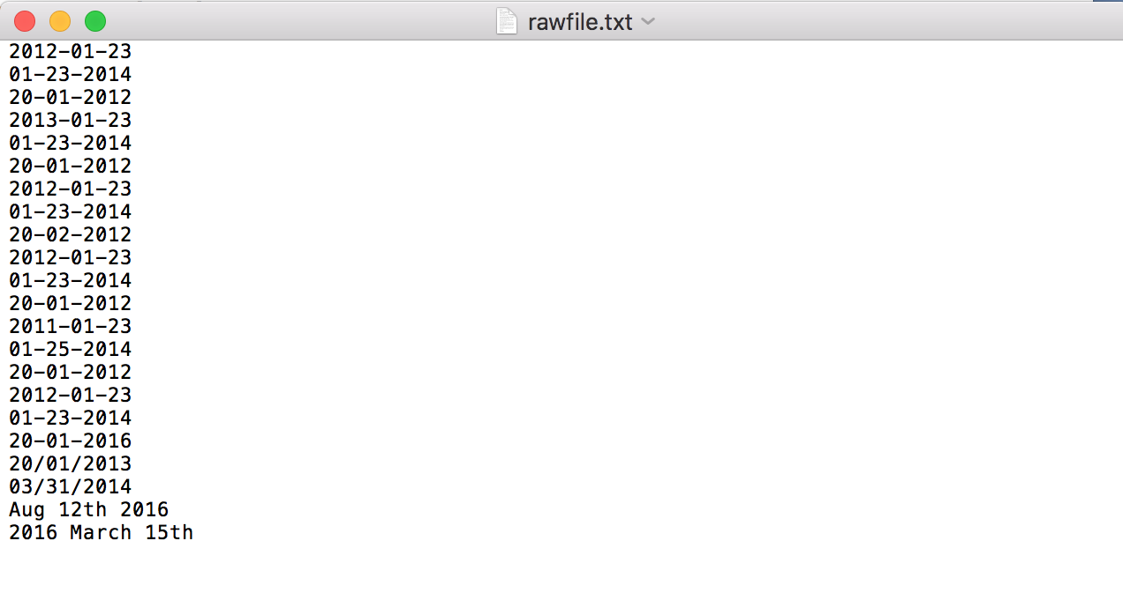

*Figure 1.2*

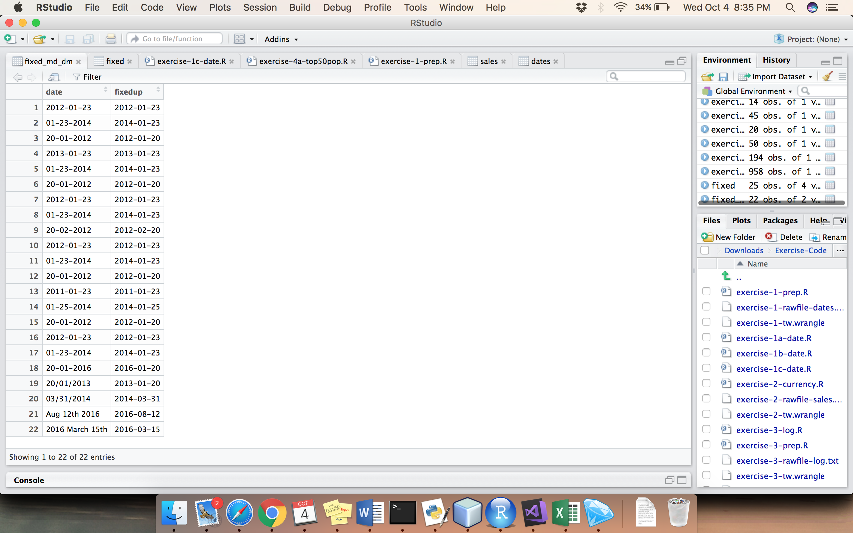

*Figure 1.3*

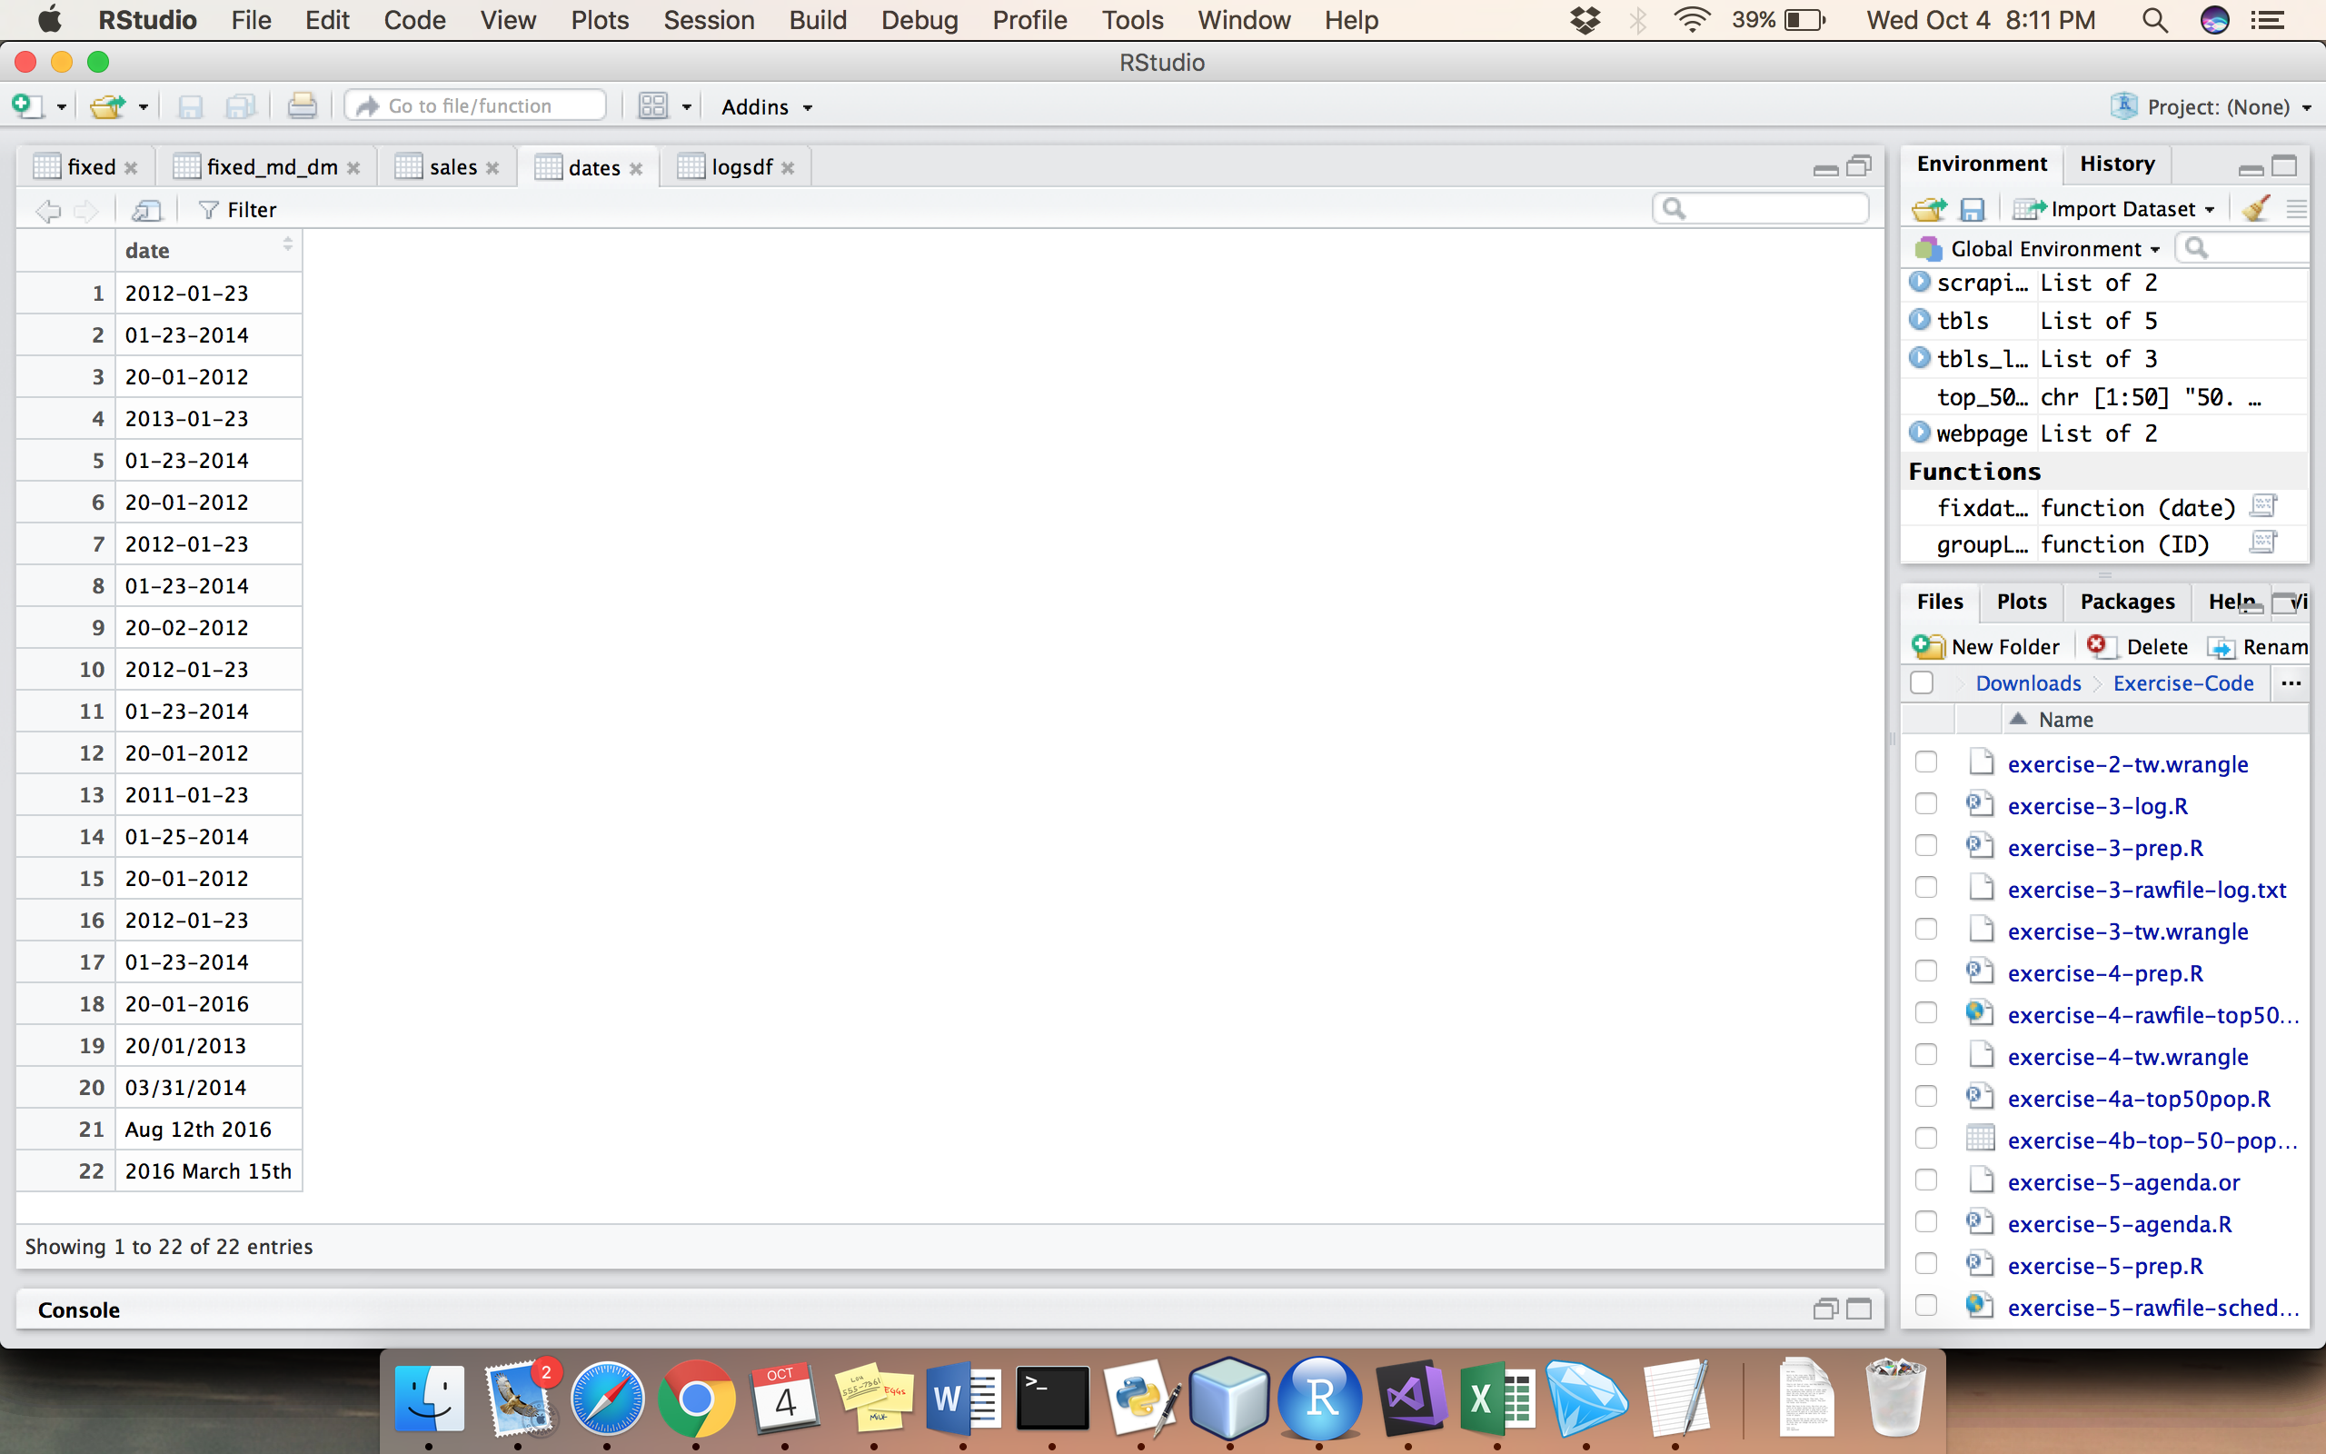

*Figure 1.4*

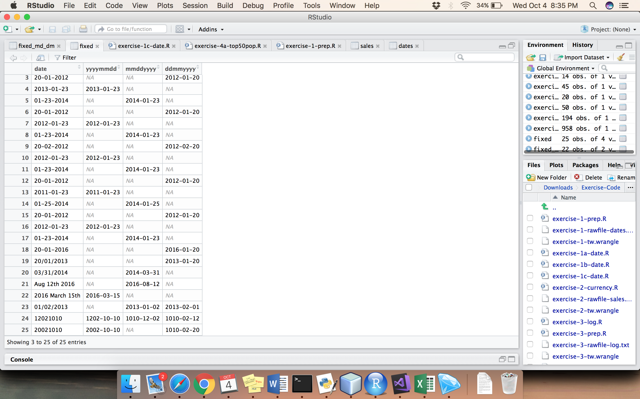

**EXERCISE 2: Fix Currency Values**

In exercise 2, the raw file has given with sales information in £, shown in figure 2.1. We are using mutate to extract currency symbol from the raw data and converting it into $ by multiplying the amount with 1.44, we have given float as datatype for amount using wrangle. Header and column information is designed shown in figure 2.2

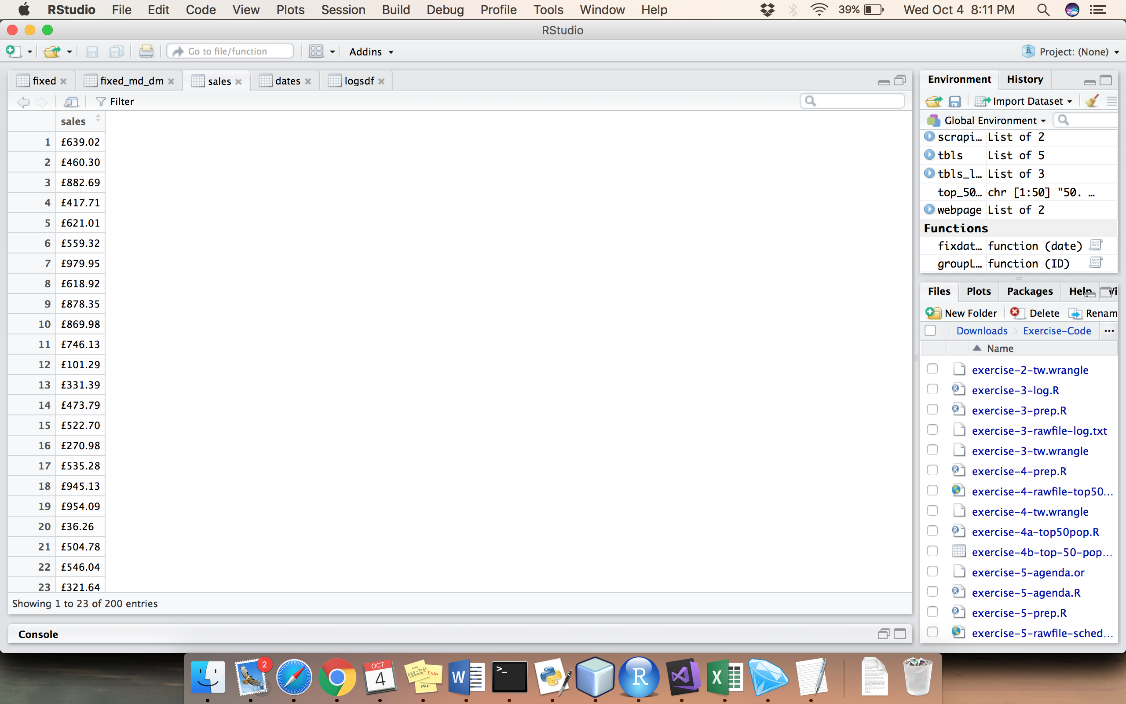

*Figure 2.1*

*Figure 2.2*

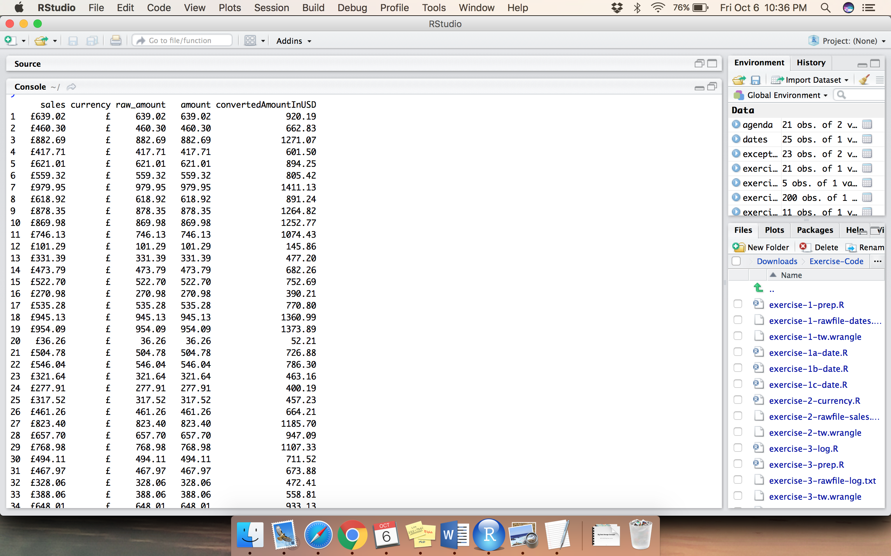

**EXERCISE 3: Fix Java Log4j Log File with Exception Stack Traces**

In exercise 3, we are using excel format hence installing openxlsx package. Input raw file has log information of 311 lines as shown in figure 3.1. The raw file is read and information is extracted and saved in logsdf file in two columns as shown in figure 3.2. By using function, class, vectors and exceptions the information in the log file is extracted in format and saved as ‘text’ file like shown in figure 3.3. columns are named as ID, time, class, message using wrangle.

*Figure 3.1*

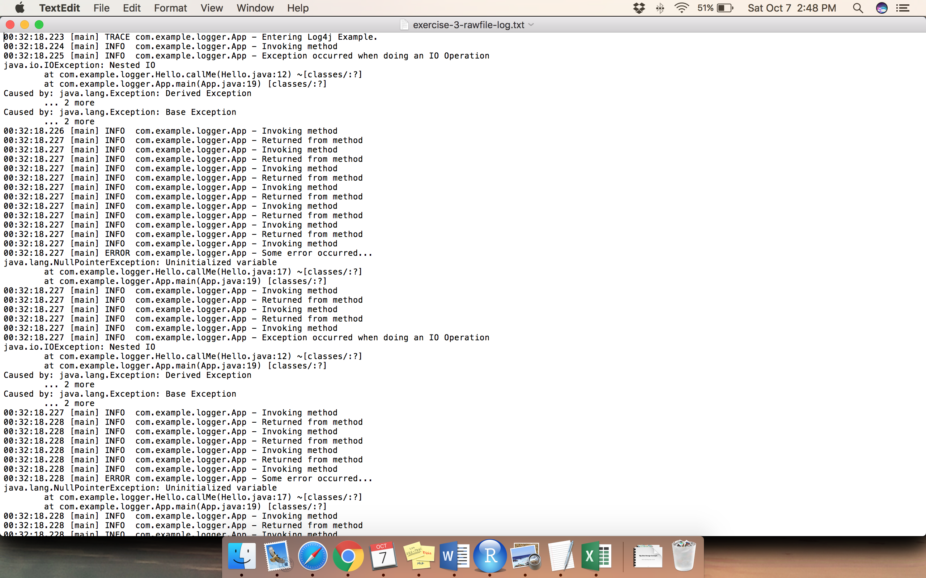

*Figure 3.2*

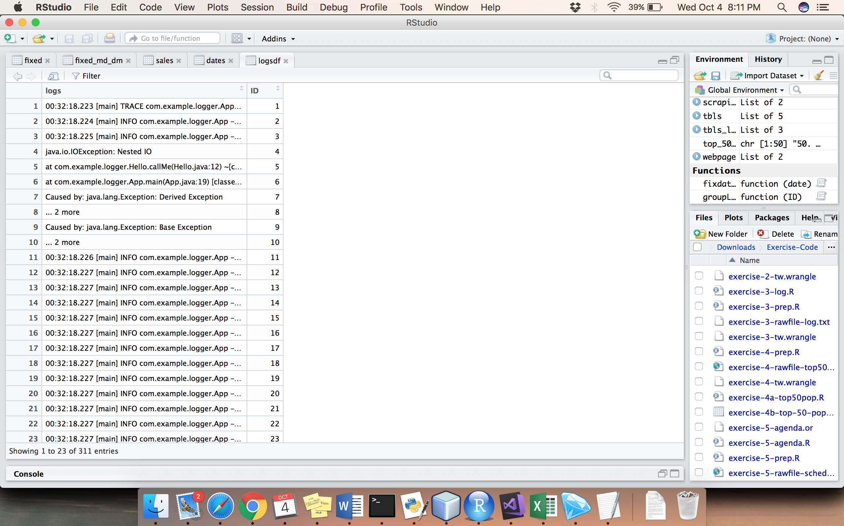

*Figure 3.3*

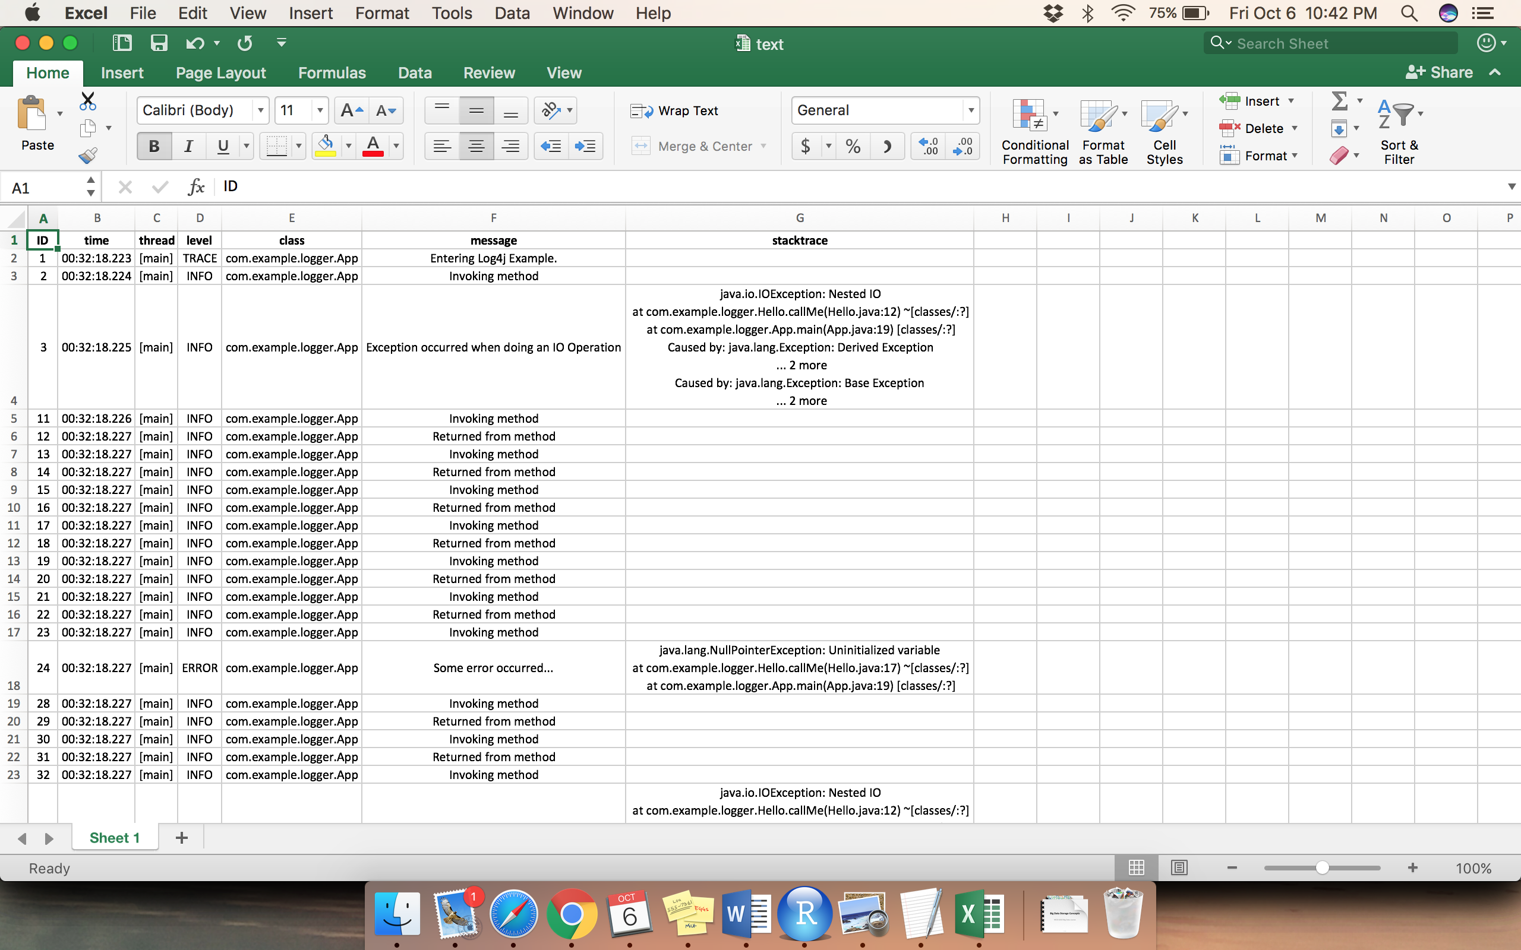

**EXERCISE 4: Web Scraping Top 50 Pop Songs in the Last Decade**

In exercise 4.a, gtools and rvest are the additional packages installed. The raw file for this exercise is a html file shown in figure 4.1. Output is written in a file named ‘top-50-pop.csv’, shown in figure 4.3, here we have used ‘|’ as a delimiter in the same column instead of writing in multiple columns. Exercise 4.b is about scraping the information from the webpage given, rvest package is useful for this operation shown in figure 4.2 which is saved in a csv/excel file.

*Figure 4.1*

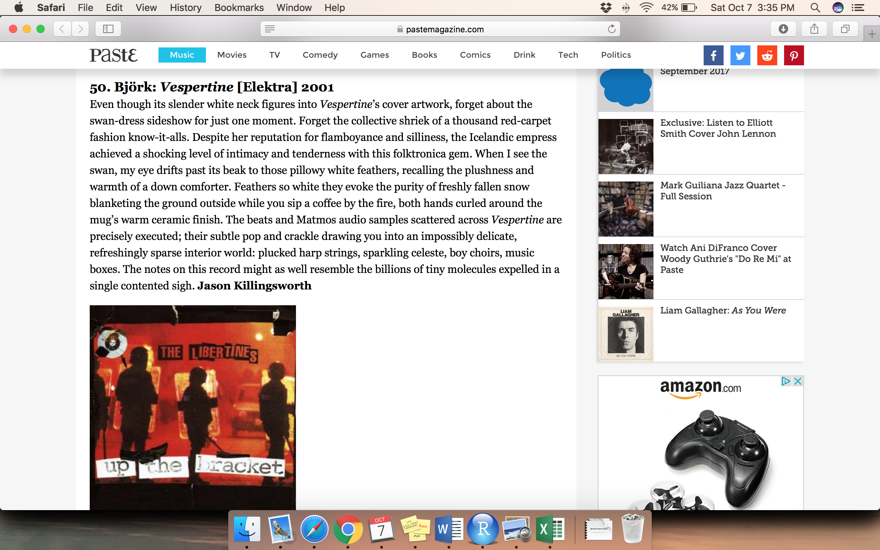

*Figure 4.2*

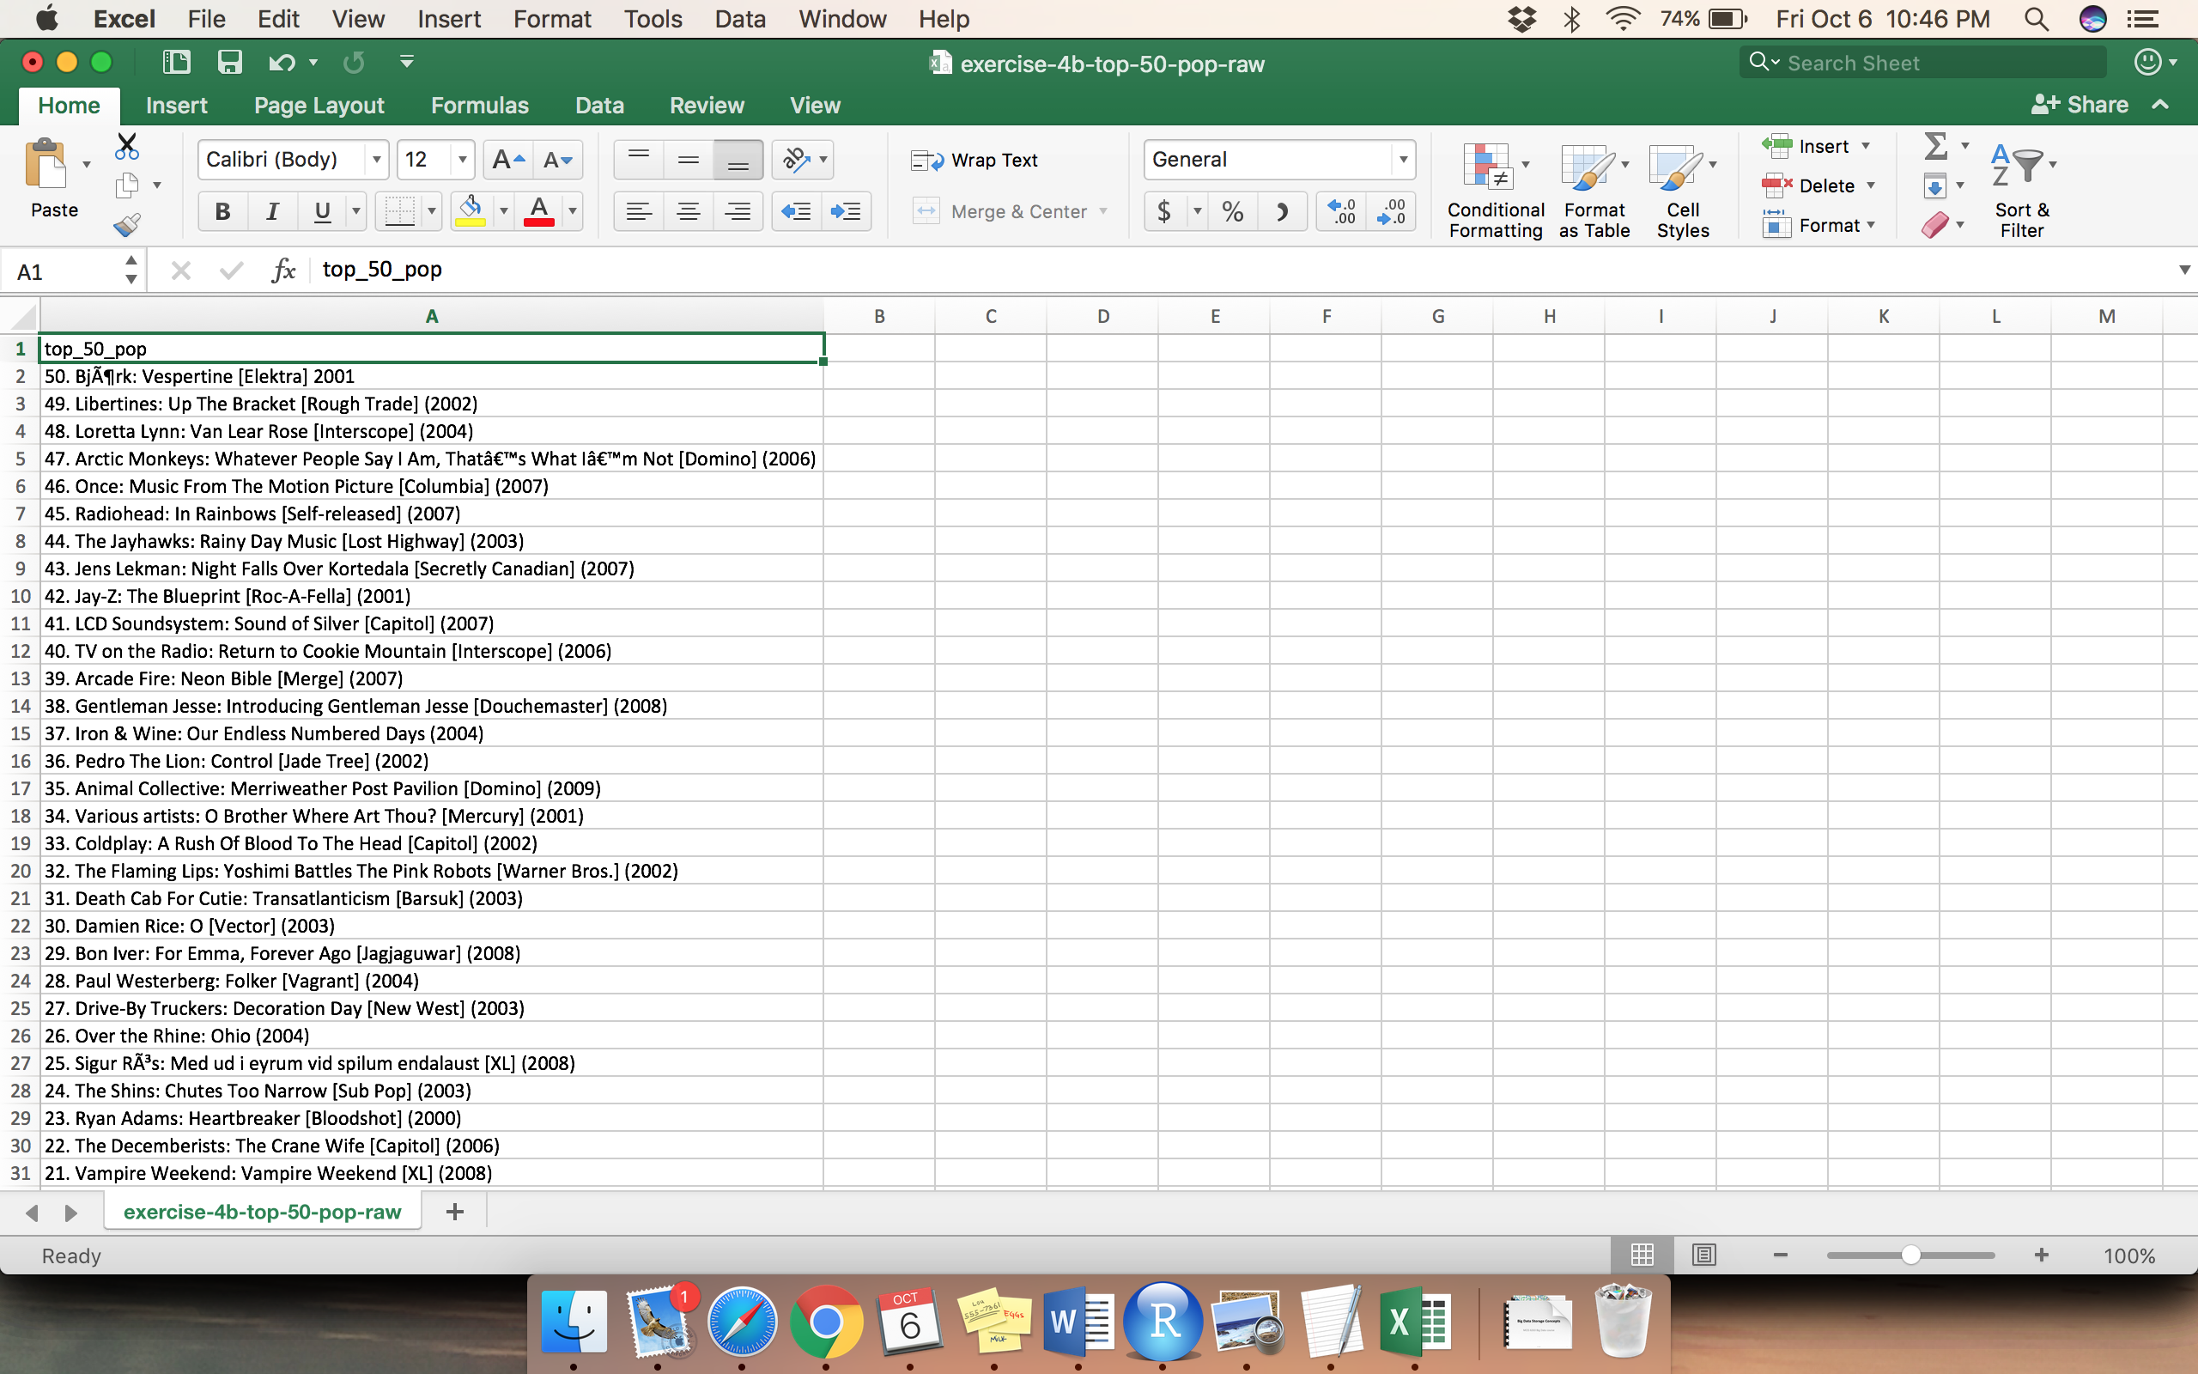

*Figure 4.3*

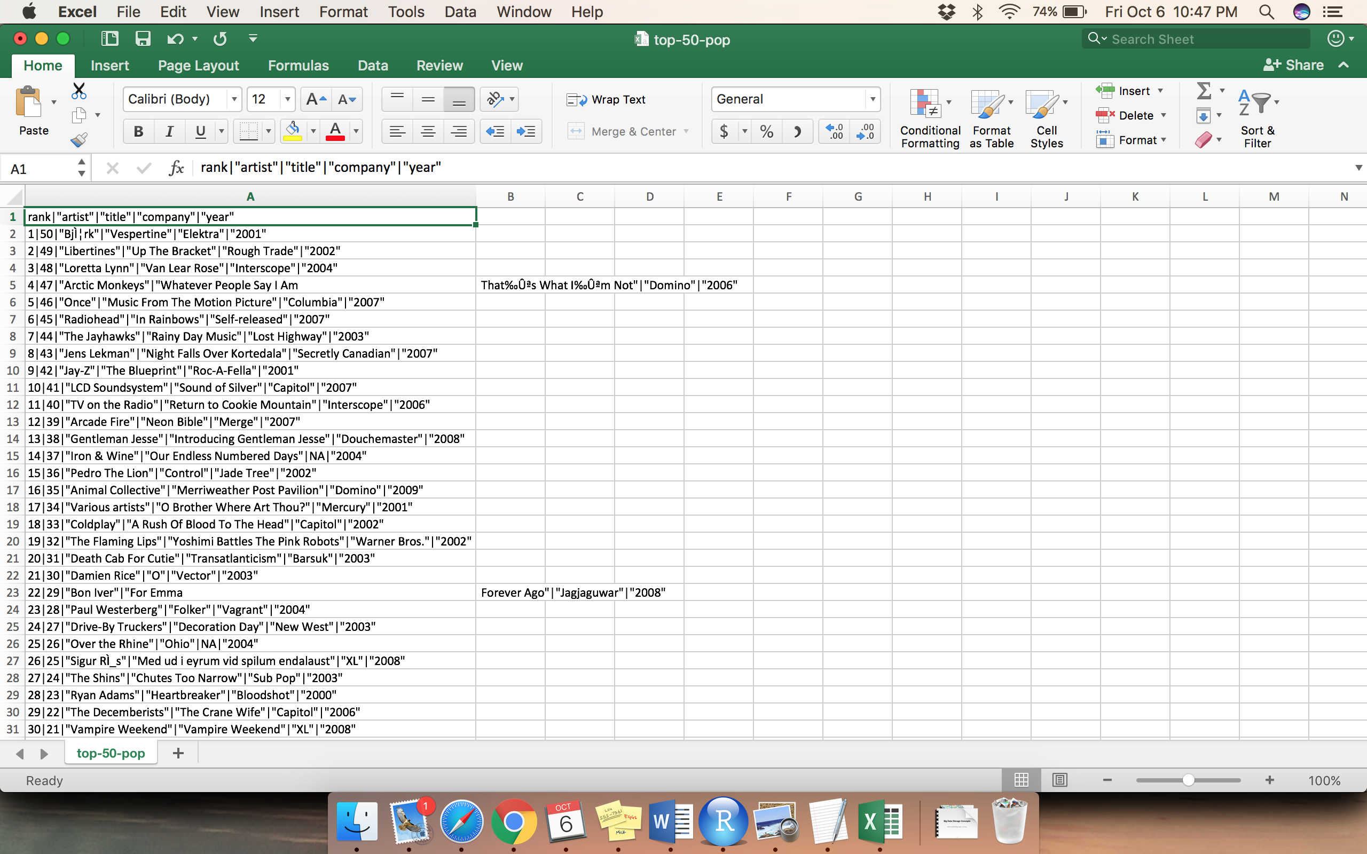

**EXERCISE 5: Web Scrape Using OpenRefine, R**

In exercise 5, we are using OpenRefine which is a desktop application used for data cleaning and formatting which is also called data wrangling. Here, we use local host connecting our system to web server. The raw data for this exercise is a schedule given on a website as shown in figure 5.1. This website link is given as input for a project in OpenRefine, it performs cleaning and transformation of data operations, extracted record’s output of 24 rows will be displayed as shown in figure 5.2.

In R-studio, we need a new package to solve this exercise named xml2 package. Data from the website is extracted and represented in a tabular format with columns information as time and session details which are stored in an excel file, ‘agenda.csv’, shown in figure 5.3.

*Figure 5.1*

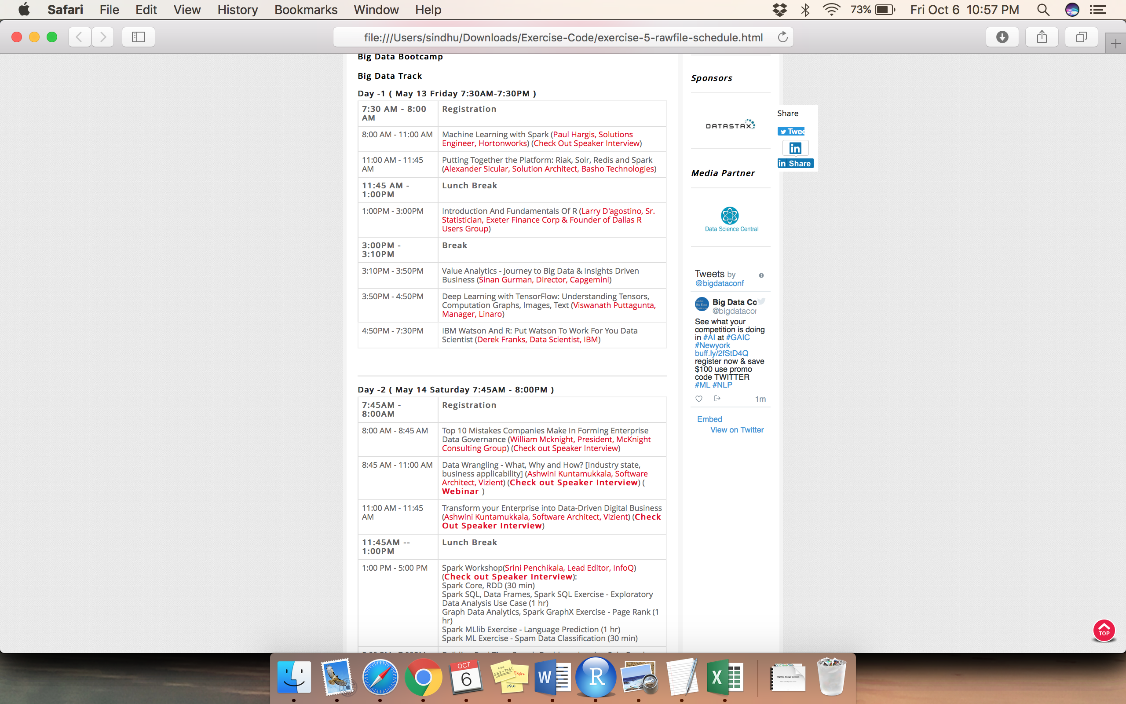

*Figure 5.2*

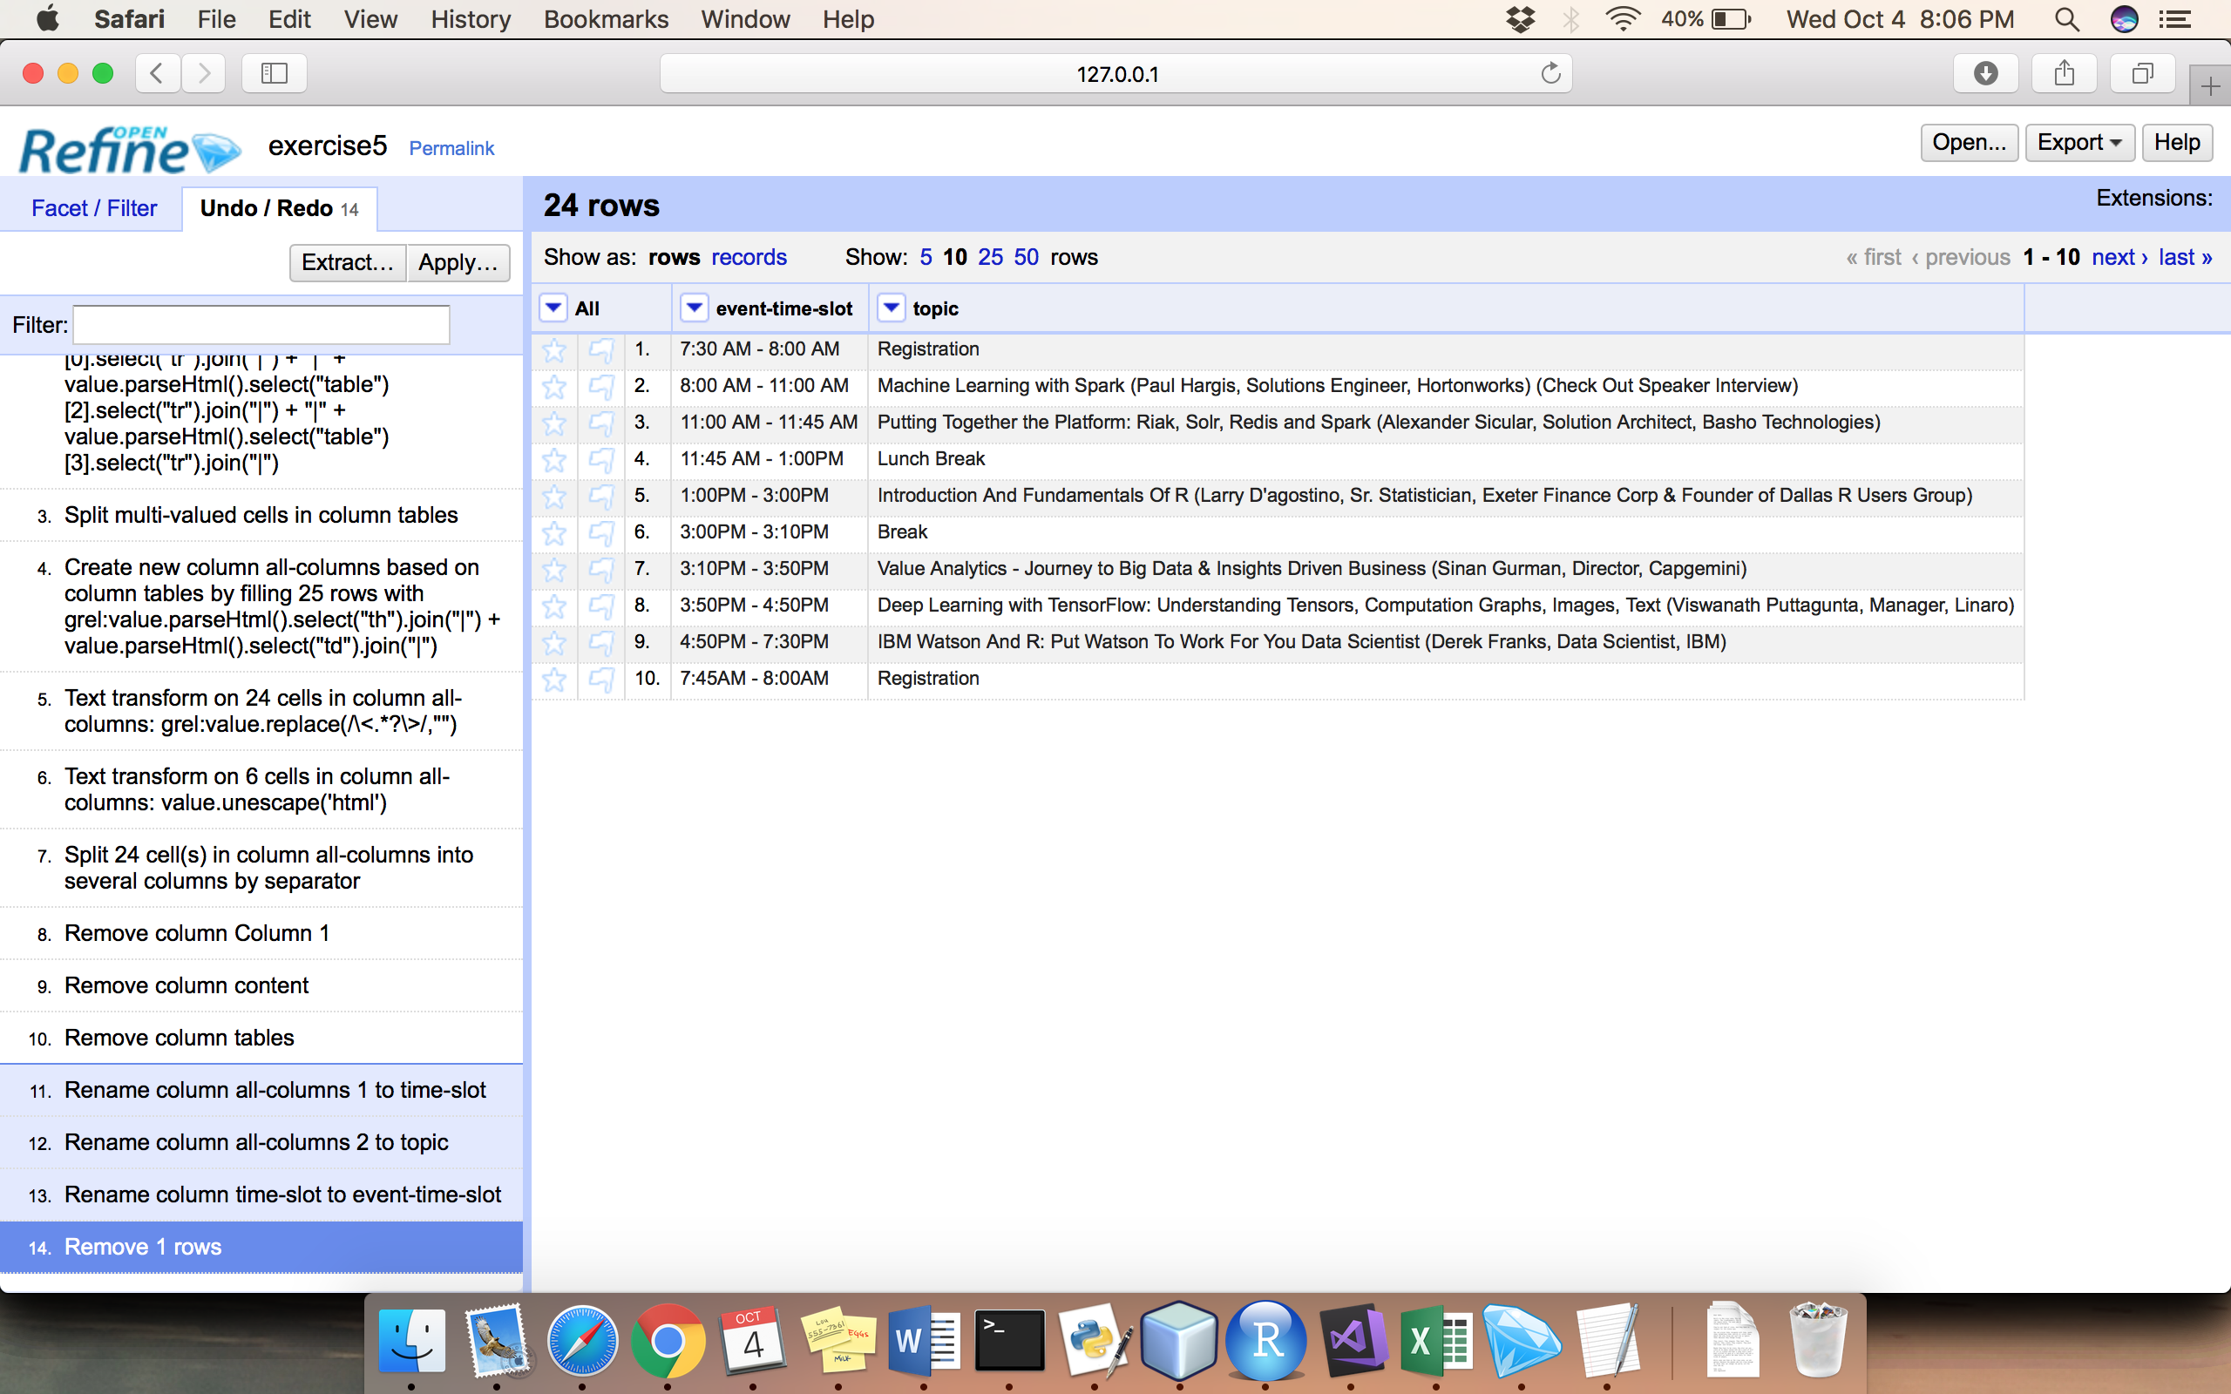

*Figure 5.3*

